**Experiment – 1**

Q1) Install JDK and IDE in your system. Write down the steps of installation with screenshots.

Ans:

**Step 1)** Right Click on the My Computer and Select the properties

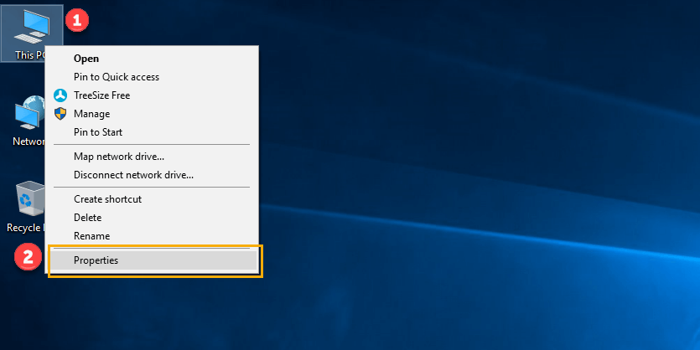

**Step 2)** Click on advanced system settings

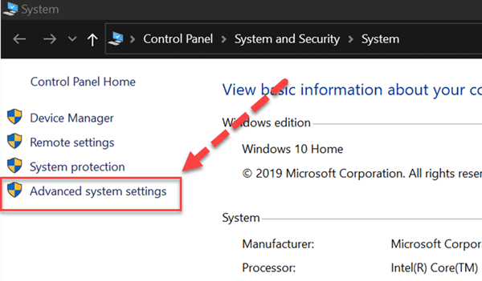

**Step 3)** Click on Environment Variables to set Java runtime environment

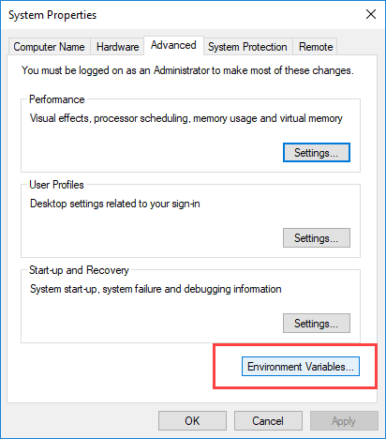

**Step 4)** Click on new Button of User variables

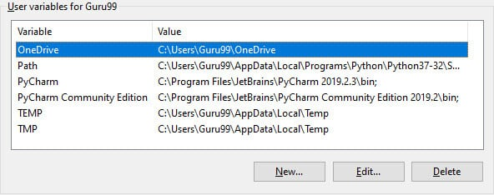

**Step 5)** Type PATH in the Variable name.

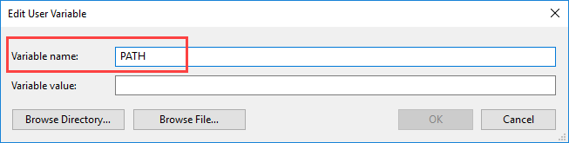

**Step 6)** Copy the path of bin folder which is installed in JDK folder.

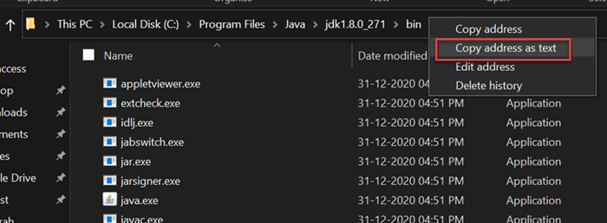

**Step 7)** Paste Path of bin folder in Variable value. Click on OK Button.

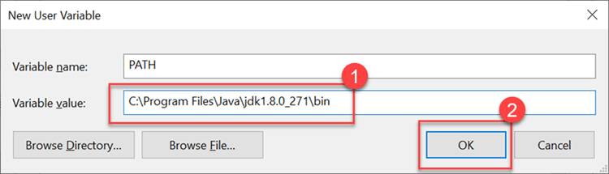

**Note:** In case you already have a PATH variable created in your PC, edit the PATH variable to

PATH = <JDK installation directory>\bin;%PATH%;

Here, %PATH% appends the existing path variable to our new value

**Step 8)** You can follow a similar process to set CLASSPATH.

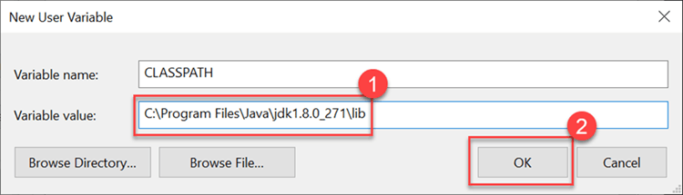

**Step 9)** Click on OK button

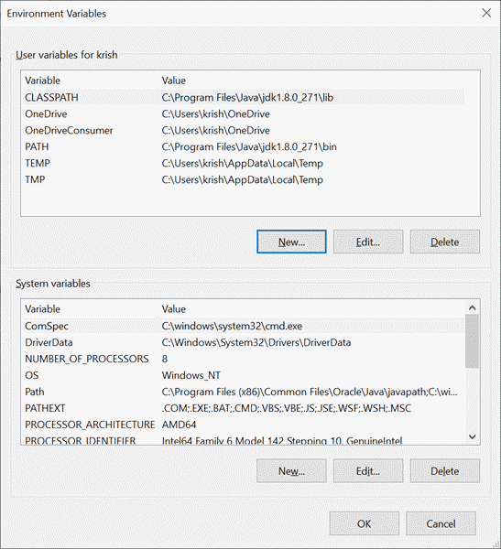

**Step 10)** Go to command prompt and type javac commands.

If you see a screen like below, Java is installed.

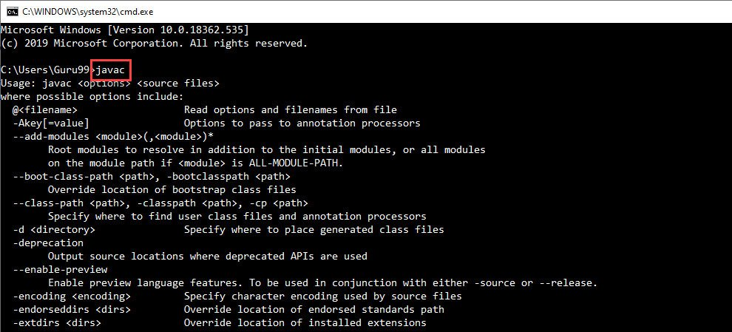

Q2) Write a Program that displays Welcome to Java, Learning Java Now and Programming is fun.

Ans:

**Program:**

package Exp_1;

public class Intro {

public static void main(String args[]){

System.out.println("Welcome to Java");

System.out.println("Learning Java Now");

System.out.println("Programming is fun");

}

}

**Output:**

Q3) Write a program that solves the following equation and displays the value x and y:

a) 3.4x+50.2y=44.5 2) 2.1x+.55y=5.9 (Assume Cramer’s rule to solve equation

b) ax+by=e x=ed-bf/ad-bc cx+dy=f y=af-ec/ad-bc )

Ans:

**Program:**

package Exp_1;

import java.util.Scanner;

public class Equations {

public static void main(String[] args) {

Scanner sc = new Scanner(System.in);

float a,b,c,d,e,f,x,y;

System.out.println("First expression: ax+by=e: ");

System.out.println("Enter values of a,b,e: ");

a = sc.nextFloat();

b = sc.nextFloat();

e = sc.nextFloat();

System.out.println("Second expression: cx+dy=f: ");

System.out.println("Enter values of c,d,f: ");

c = sc.nextFloat();

d = sc.nextFloat();

f = sc.nextFloat();

x = ((e*d)-(b*f))/((a*d)-(b*c));

y = ((a*f)-(e*c))/((a*d)-(b*c));

System.out.println("X = " + x + " Y = " + y);

sc.close();

}

}

**Output:**

Q4) Write a program that reads a number in meters, converts it to feet, and displays the result.

Ans:

**Program:**

package Exp_1;

import java.util.Scanner;

public class Length {

public static void main(String[] args) {

Scanner sc = new Scanner(System.in);

System.out.println("Enter length in meters: ");

double meters = sc.nextDouble();

double feet = meters * 3.28;

System.out.println("Length in feet = "+feet);

sc.close();

}

}

**Output:**

Q5) Body Mass Index (BMI) is a measure of health on weight. It can be calculated by taking your weight in kilograms and dividing it by the square of your height in meters. Write a program that prompts the user to enter weight in pounds and height in inches and displays the BMI.

Note:- 1 pound=.45359237 Kg and 1 inch=.0254 meters.

Ans:

**Program:**

package Exp_1;

import java.util.Scanner;

public class Dimensions {

public int square(int n){

return n*n;

}

public static void main(String args[]){

Scanner sc = new Scanner(System.in);

double weightPounds,heightInches,weightKgs,heightMeters;

System.out.print("Enter weight in pounds: ");

weightPounds = sc.nextDouble();

System.out.print("Enter height in inches: ");

heightInches = sc.nextDouble();

weightKgs = weightPounds * 0.45359237;

heightMeters = heightInches * 0.0254;

double heightSq = heightMeters * heightMeters;

double bmi = weightKgs / heightSq;

System.out.println("Your BMI is " + bmi);

sc.close();

}

}

**Output:**

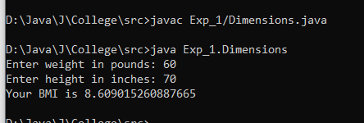

Q6) Write a program that prompts the user to enter three integers and display the integers in decreasing order.

Ans:

**Program:**

package Exp_1;

import java.util.Scanner;

public class Max3Nos {

public static void func(int a, int b, int c) {

if(a>b && a>c){ // a is max

if(b>c){ // b is second max

System.out.println(a+" "+b+" "+c);

}

else{ // c is second max

System.out.println(a+" "+c+" "+b);

}

}

}

public static void main(String[] args) {

Scanner sc = new Scanner(System.in);

int a,b,c;

System.out.print("Enter 3 numbers: ");

a = sc.nextInt();

b = sc.nextInt();

c = sc.nextInt();

func(a,b,c);

func(b,a,c);

func(c,a,b);

sc.close();

}

}

**Output:**

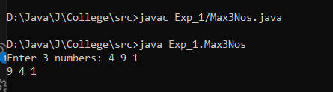

Q7) Write a program that prompts the user to enter a letter and check whether a letter is a vowel or constant

Ans:

**Program:**

package Exp_1;

import java.util.Scanner;

public class VowelConsonant {

    public static void main(String[] args) {

        Scanner sc = new Scanner(System.in);

        String ch;

        System.out.println("Enter character: ");

        ch = sc.next();

        if (ch.equals("A") || ch.equals("E") || ch.equals("I") ||

                ch.equals("O") || ch.equals("U") ||

                ch.equals("a") || ch.equals("e") || ch.equals("i") ||

                ch.equals("o") || ch.equals("u") ) {

            System.out.println("Vowel");

        }

        else{

            System.out.println("Consonant");

        }

        sc.close();

    }

}

**Output:**

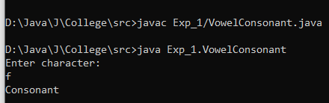

Q8) A cashier has currency notes of denominations 1, 2, 5, 10, 50 and 100. If the amount to be withdrawn is input through the keyboard, find the total number of currency notes of each denomination the cashier will have to give to the withdrawer.

Ans:

**Program:**

package Exp_1;

import java.util.Scanner;

public class Denominations {

    public static void main(String[] args) {

        Scanner sc = new Scanner(System.in);

        System.out.print("Enter the amount to withdraw: ");

        int amount = sc.nextInt();

        int hundred = amount / 100;

        amount %= 100;

        int fifty = amount / 50;

        amount %= 50;

        int ten = amount / 10;

        amount %= 10;

        int five = amount / 5;

        amount %= 5;

        int two = amount / 2;

        amount %= 2;

        int one = amount;

        if (hundred > 0) System.out.println("100 x " + hundred);

        if (fifty > 0) System.out.println("50 x " + fifty);

        if (ten > 0) System.out.println("10 x " + ten);

        if (five > 0) System.out.println("5 x " + five);

        if (two > 0) System.out.println("2 x " + two);

        if (one > 0) System.out.println("1 x " + one);

        sc.close();

    }

}

**Output:**

Q9) If a five-digit number is input through the keyboard, write a program to print a new number by adding one to each of its digits. For example, if the number that is input is 12391 then the output should be displayed as 23502.

Ans:

**Program:**

package Exp_1;

import java.util.Scanner;

public class AddOnes {

    public static void main(String[] args){

        Scanner sc = new Scanner(System.in);

        System.out.print("Enter a number: ");

        int n = sc.nextInt();

        int sum = n + 11111;

        System.out.println(sum);

        sc.close();

    }

}

**Output:**

Q10) If lengths of three sides of a triangle are input through the keyboard, write a program to print the area of the triangle.

Ans:

**Program:**

package Exp_1;

import java.util.Scanner;

import java.lang.Math;

public class AreaTriangle{

    public static double areaTriangle(float a, float b, float c){

        float s = (a+b+c)/2;

        double areaSquared = s*(s-a)*(s-b)*(s-c);

        return Math.sqrt(areaSquared);

    }

    public static void main(String[] args){

        Scanner sc = new Scanner(System.in);

        System.out.println("Enter each side of the triangle: ");

        float a = sc.nextFloat();

        float b = sc.nextFloat();

        float c = sc.nextFloat();

        System.out.println("Area : " + areaTriangle(a,b,c) + " m^2");

        sc.close();

    }

}

**Output:**

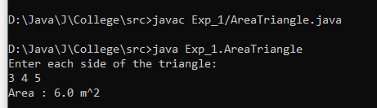

Q11) Write a program to produce the following patterns.

|  |  |
| --- | --- |
| **\*\*\*\***  **\*\*\***  **\*\***  **\*** | 1234  123  12  1 |
| 1234  567  89  0 | **\***  **\*\*\***  **\*\*\*\*\***  **\*\*\*\*\*\*\***  **\*\*\*\*\***  **\*\*\***  **\*** |

Ans:

**Program:**

package Exp_1;

import java.util.Scanner;

public class Pattern {

    public static void main(String[] args){

        Scanner sc = new Scanner(System.in);

        System.out.print("Enter n: ");

        int n = sc.nextInt();

        System.out.println("Pattern 1.");

        for(int i=1;i<=n;i++){

            for(int j=n;j>=i;j--){

                System.out.print("*");

            }

            System.out.print("\n");

        }

        System.out.print("Enter n2: ");

        int n2 = sc.nextInt();

        System.out.println("Pattern 2.");

        for(int i=n2;i>=0;i--){

            for(int j=1;j<=i;j++){

                System.out.print(j);

            }

            System.out.print("\n");

        }

        System.out.print("Enter n3: ");

        int n3 = sc.nextInt();

        System.out.println("Pattern 3.");

        int a=1;

        for(int i=n3;i>=0;i--){

            for(int j=1;j<=i;j++){

                System.out.print(a);

                a+=1;

            }

            System.out.print("\n");

        }

        System.out.println("Pattern 4.");

        System.out.print("Enter n4: ");

        int n4 = sc.nextInt();

        int nsp = n4-1;

        int nst = 1;

        for(int i = 1; i<=2*n4-1;i++)

        {

            for(int j=1;j<=nsp;j++)

            {

                System.out.print(" ");

            }

            for(int k =1;k<=nst;k++)

            {

                System.out.print("*");

            }

            if (i < n4) {

                nsp--;

                nst += 2;

            } else {

                nsp++;

                nst -= 2;

            }

            System.out.print("\n");

        }

        sc.close();

    }

}

**Output:**

